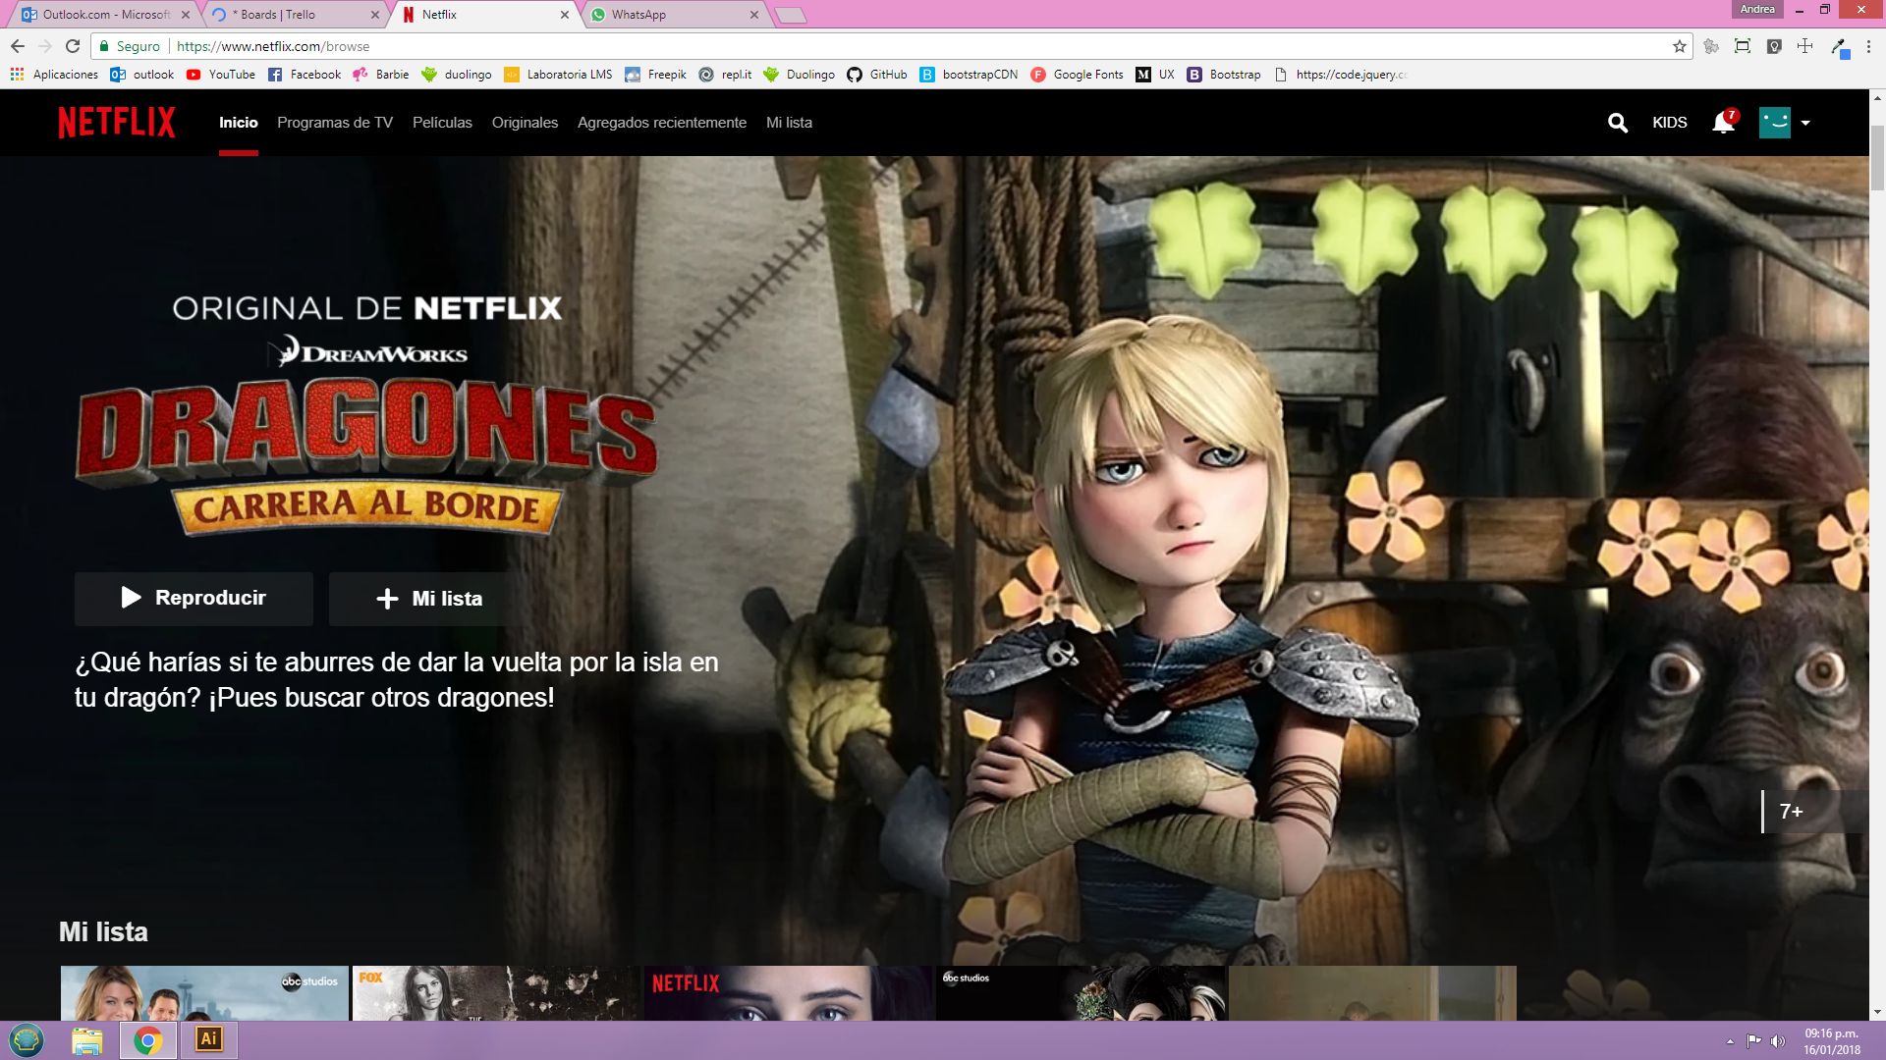

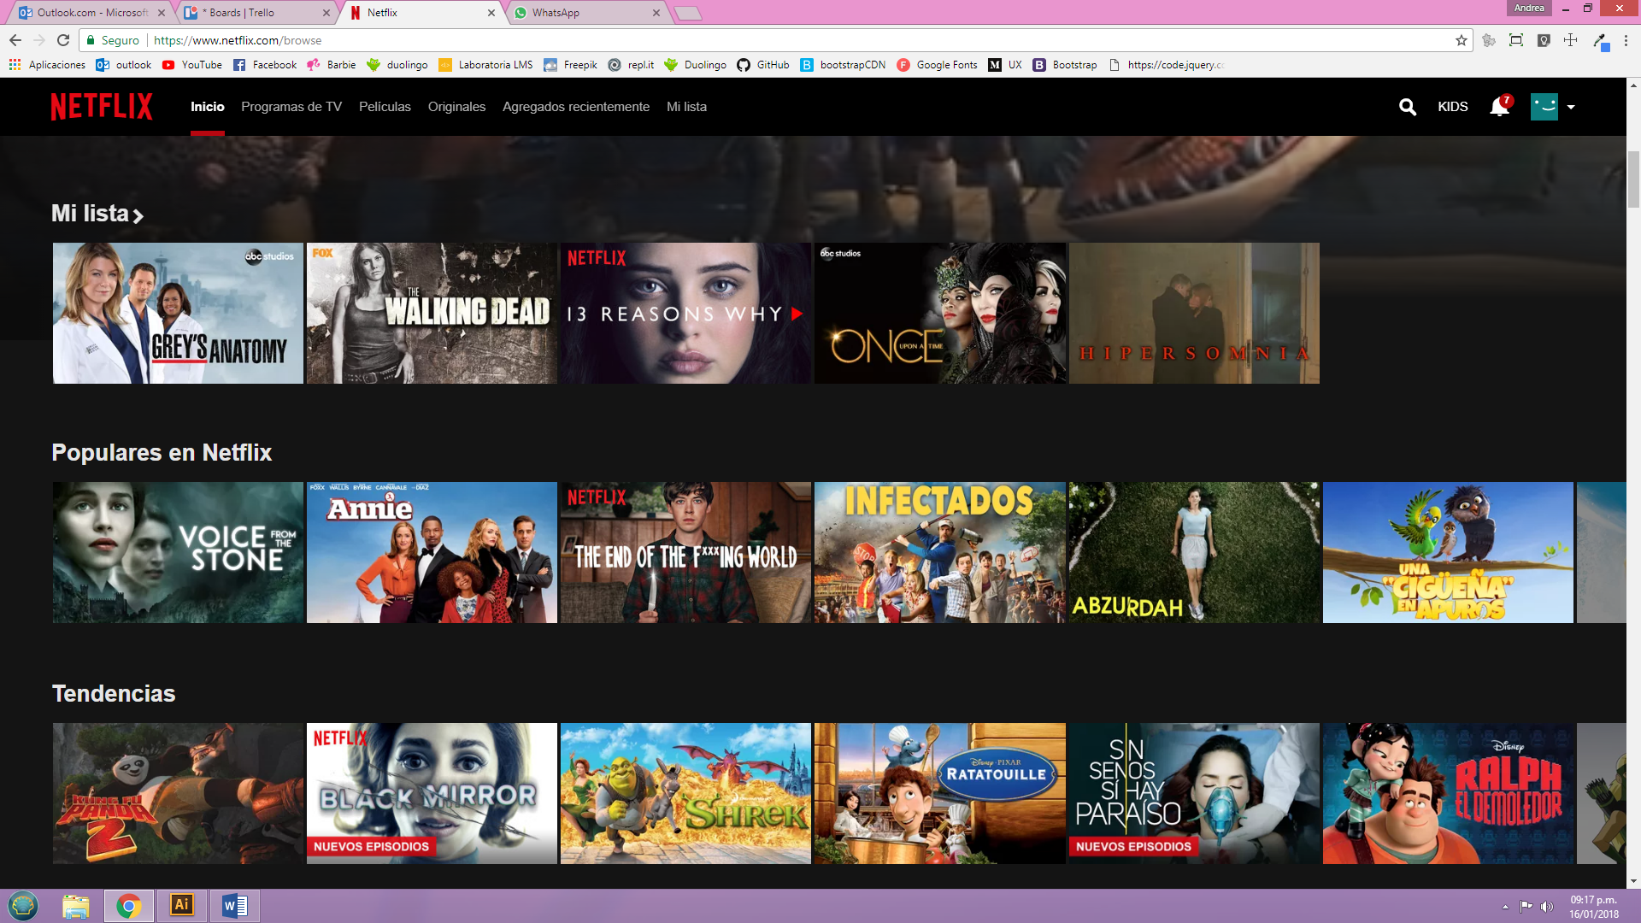

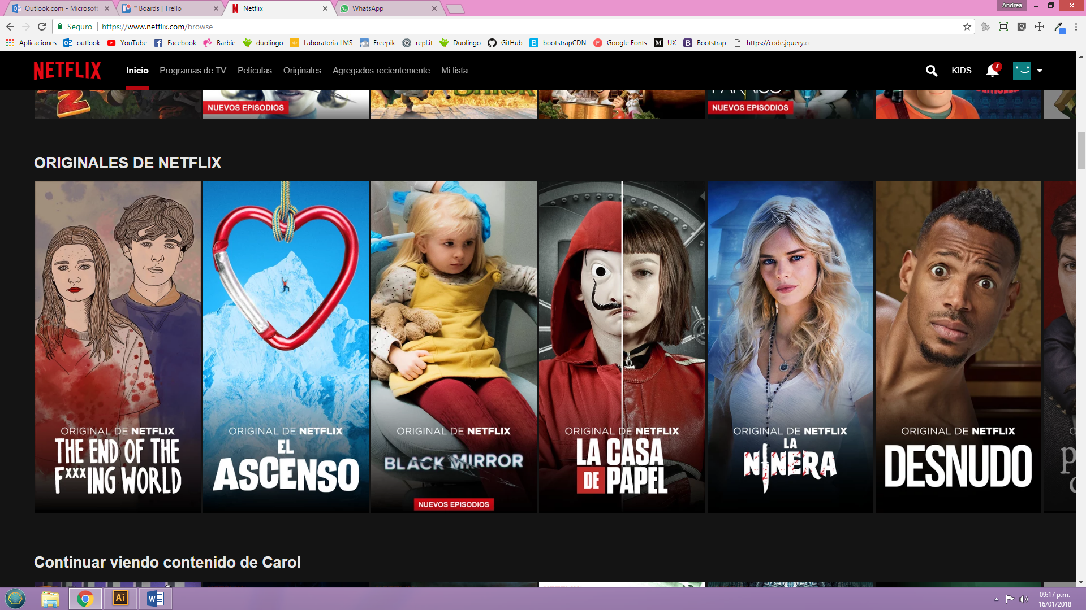

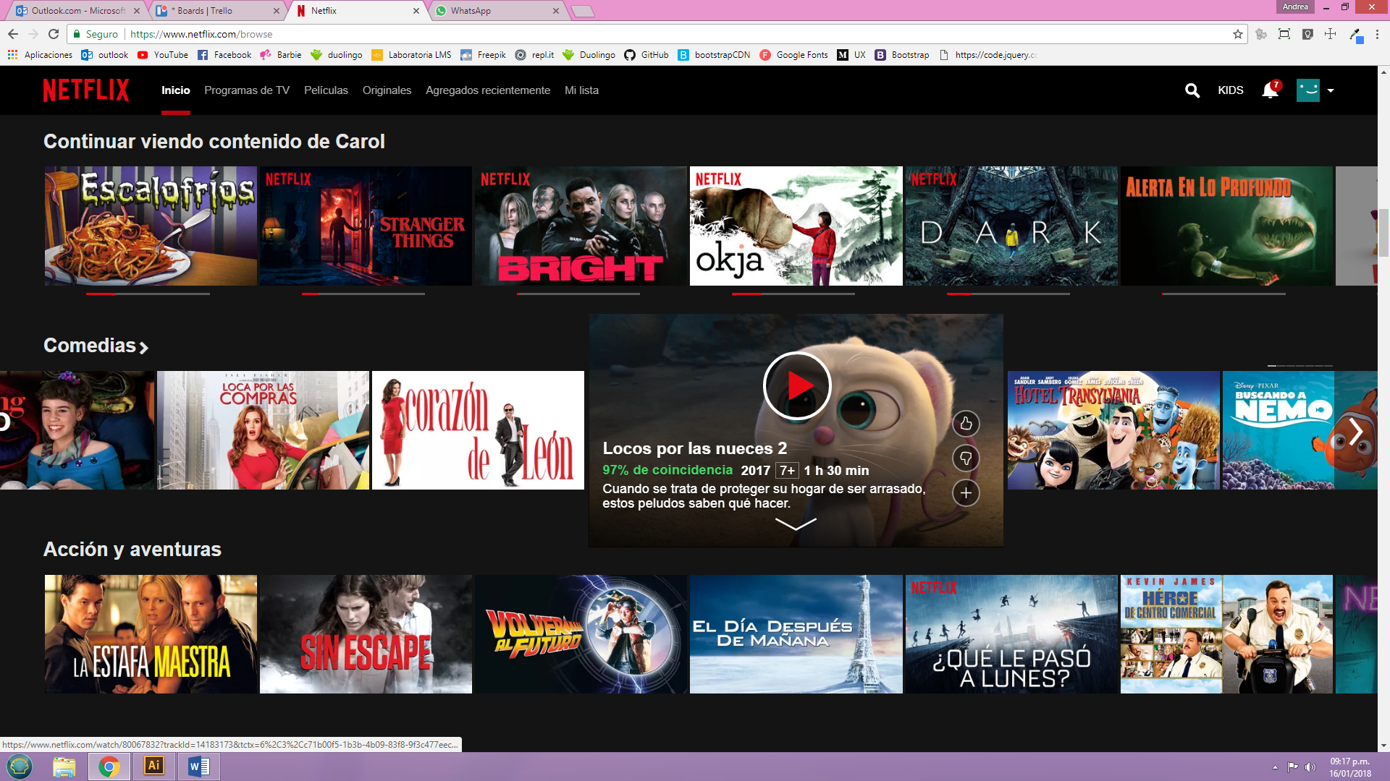



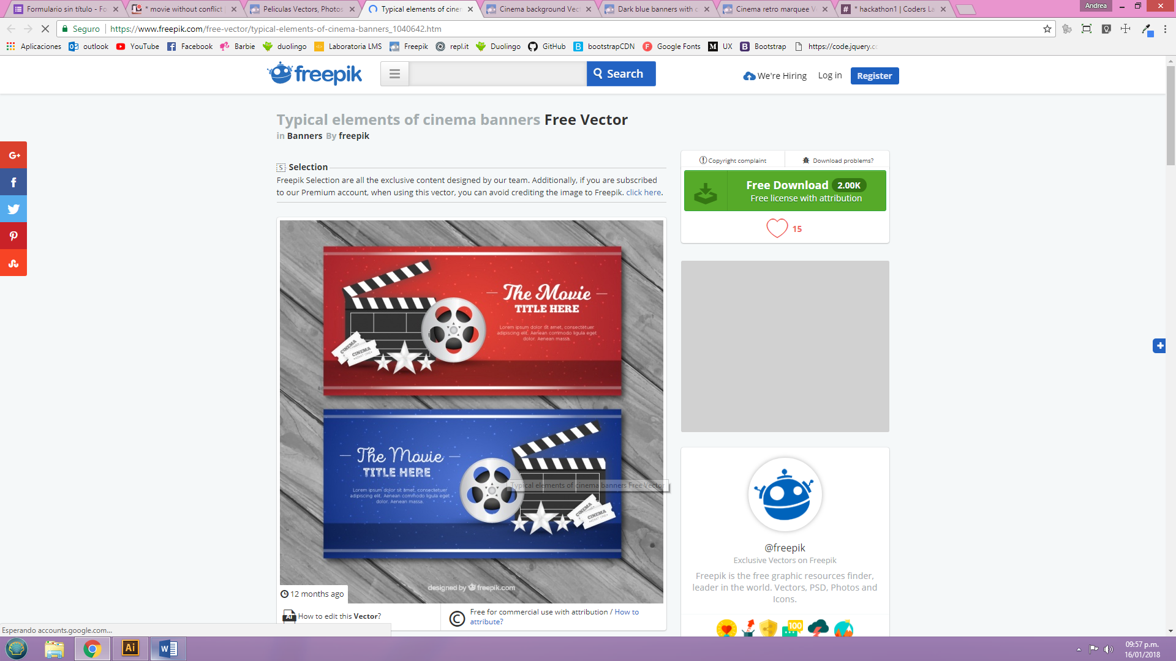

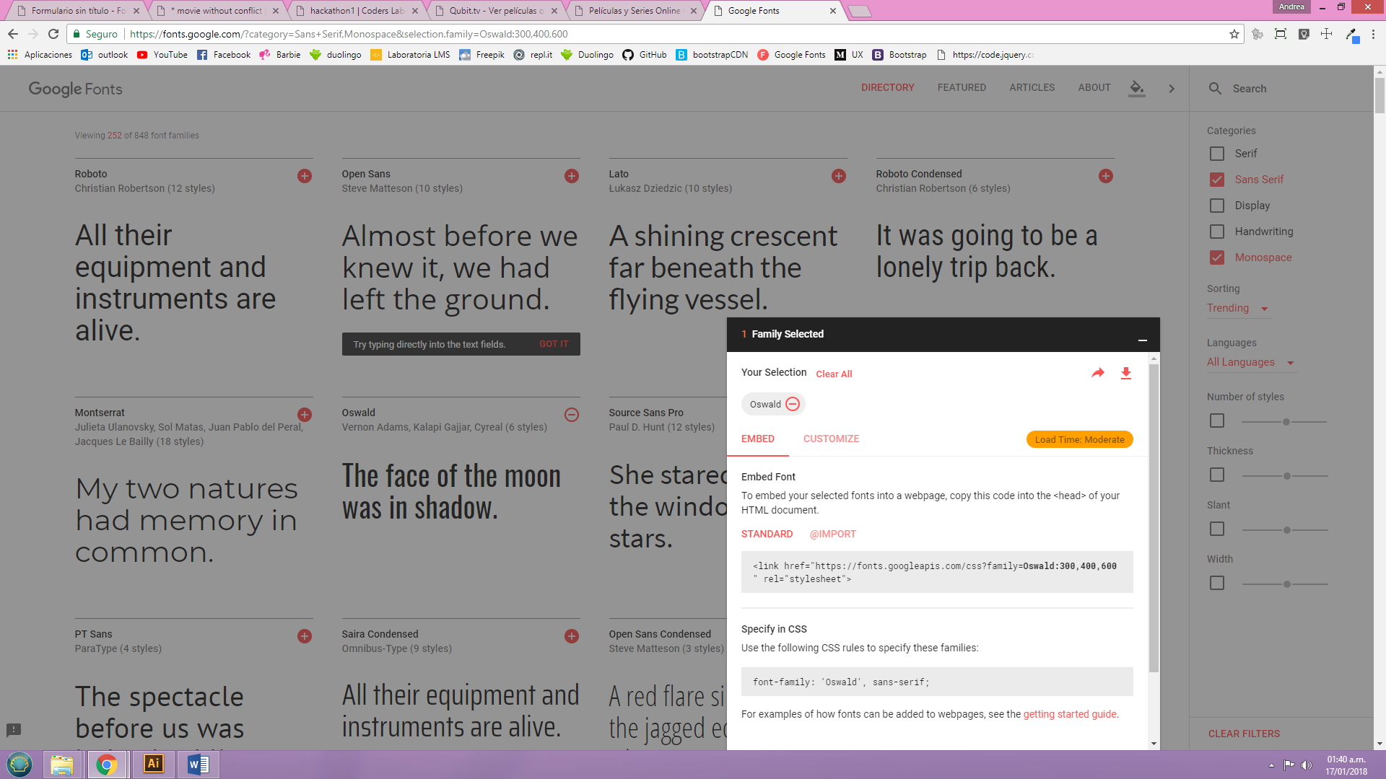

<http://www.cliver.tv/>

<https://pe.qubit.tv/inicio/>

<https://docs.google.com/forms/d/1Iy-Yh9Jw3uY04fCxlcsrEo0-u6TfILfllUKSdGyNcoI/edit?ts=5a5eb829#responses>

https://trello.com/b/VzciMTWm/movie-without-conflict